In-Home Safety Services (IHSS) Financial Handout
Financial Contacts:
- Dave Berndt
IHSS Financial Manager
(608) 422-6198
David.Berndt@wisconsin.gov

- Sara Schwoch
DCF SPARC Accountant
(608) 422-6397
Sara2.Schwoch@wisconsin.gov

- General IHSS Questions
DCFIHSSProgram@wisconsin.gov

Contract Summary:
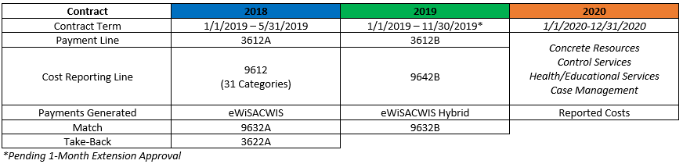
Timelines:

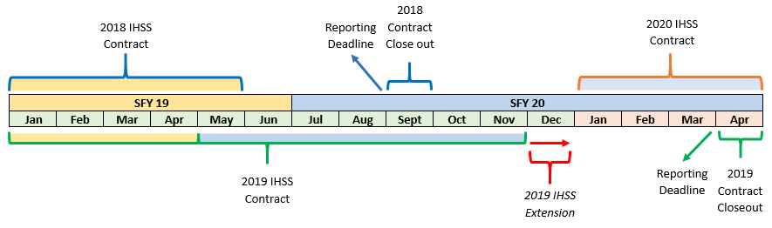
2018 Reconciliation
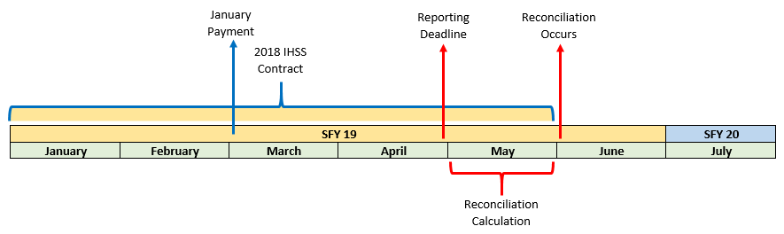
2018 Contract Closeout
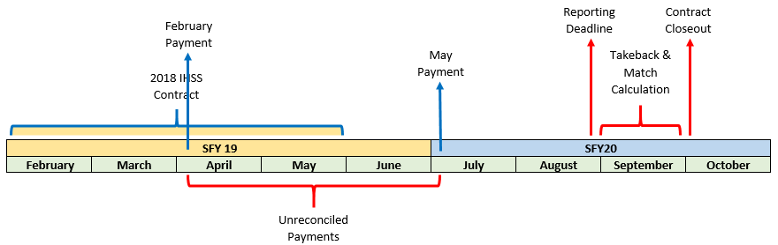

2019 Contract Closeout
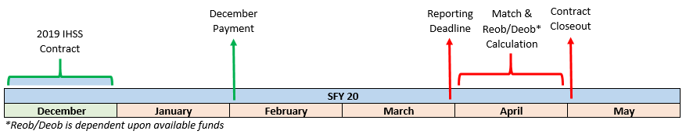

2020 Contract Closeout
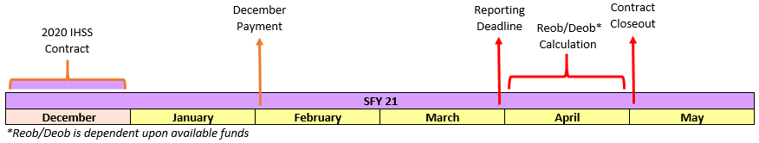

Targeted Safety Support (TSS) Funds Reporting:
Concrete Resources

- Food/Clothing Services
Old IHSS Crosswalk Example
- Housing Assistance
- Transportation
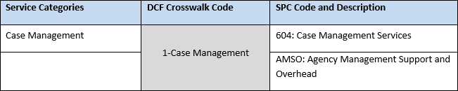
- Household Support

Control Services
Separation:
- Recreational Activities
- Daycare
- Respite
Social Connection and Emotional Support
Service Categories
DRAFT
- Social Supports
Supervision and Monitoring
- Supervision/Observation
Parenting and Home Management
- Basic Home Management
- Unique Child Condition Service
- Basic Parenting Assistance

Psychological Intervention/Health Services/Education
Medical Services
- In-Home Health Care
TSS SPARC Categories
Crisis Management
- Crisis Services
- Mental Health and AODA Services
Change Services
- Parenting Education

Case Management
- Case Management Service

